Hardware Implementation of Multi-Mode Keccak Core for Kyber

Design Project
Submitted in partial fulfillment of the requirements of ECE/EEE F366 Laboratory Project
By
Sriharsha Tippavajhala
Dhananjay Rao T S
Amit Narayan Satpathy
ID No. 2021AAPS0717H, 2021AAPS0321H, 2021AAPS2127H
Under the supervision of:
Prof. Subhendu Kumar Sahoo


BIRLA INSTITUTE OF TECHNOLOGY AND SCIENCE PILANI, HYDERABAD CAMPUS
December 2024

Certificate

This is to certify that the report entitled, “Hardware Implementation of Multi-Mode Keccak Core for Kyber” and submitted by Sriharsha Tippavajhala, Dhananjay Rao T S, Amit Narayan Satpathy ID No. 2021AAPS0717H, 2021AAPS0321H, 2021AAPS2127H in partial fulfillment of the requirements of ECE/EEE F366 Lab Project embodies the work done by him under my supervision.

Supervisor
Prof. Subhendu Kumar Sahoo Faculty,
BITS-Pilani Hyderabad Campus

Abstract
Hardware Implementation of Multi-Mode Keccak Core for Kyber

With the rise of Quantum Computers and Shor’s algorithm, Post quantum cryptography has gained a lot of traction and is a very active research area.The NIST-approved algorithm of CRYSTALS-Kyber is a prominent post quantum cryptographic algorithm which helps with key encapsulation.The hash function SHA 3 is a integral part of this system and is the bottom neck of resource consumption and this project focuses on implementing a hardware friendly, low-resource-consuming keccak core with the functionality of 4 modes that are SHA3-512, SHA3-256, SHAKE-128, SHAKE-256.

Acknowledgements

I would like to express my gratitude to Prof. Subhendu Kumar Sahoo for supervising the project and providing invaluable guidance. I would also like to thank my teammates for their constant effort to make my work possible.
I would like to extend my gratitude to Birla Institute of Technology and Science, Hyderabad Campus for providing me with facilities without which this Project would not be possible. This project would not be possible without their contributions.

Contents
Hardware Implementation of Multi-Mode Keccak Core for Kyber 1
Certificate 2
Abstract 3
Acknowledgements 4
1. Introduction 6
Overview 6
2. SHA3 (Secure Hash Algorithm) 7
Key Concepts 7
Padding 8
F Permutation 8
Absorbing 10
Squeezing 10
3. Literature Review 11
4. Hardware Implementation 15
Padder: 15
FIFO(First In First Out): 20
SIPO(Serial In Parallel Out): 23
F(permutation function): 25
Rconst: 29
Round: 30
PISO(Parallel In Serial Out): 31
Keccak_v1(Top): 35
Keccak_tb(testbench): 40
5. Bibliography 41

Introduction

Overview
Qunatum computers pose a hazard to the security of all present day crypto-systems by using shor’s algorithm-Algorithm developed by Peter Shor to factorise large numbers using quantum computers which in turn make discrete log problem solvable. Due to this, ECC,RSA,Diffie Helman are broken. So we need Post Quantum Cryptography which lean on Module LWE(Learning with errors) and CRYSTALS-Kyber is a NIST-approved algorithm.
Hash Module plays an important role of generating coefficients required for key encapsulation. Kyber specifies that SHA3 algorithms be used for it. There are 4 variations of it namely, SHA3-512,SHA3-256, SHAKE 128,SHAKE 256.All these 4 utilise the same core for hashing which is the keccak core.
Key components of Keccak Core:
- Padding Phase
- Absorption Phase
- Squeezing Phase

SHA3 (Secure Hash Algorithm)

Key Concepts

r - rate of hashing
c- capacity
l-the binary logarithm of the lane size
rounds = 12+2l
state size(b) = r+c = 25 * 2^{l}
state = {r,c}
For our use case, we will using one lane as 64 so l = 6 and the state array as 1600 bits with 64 5x5 arrays.
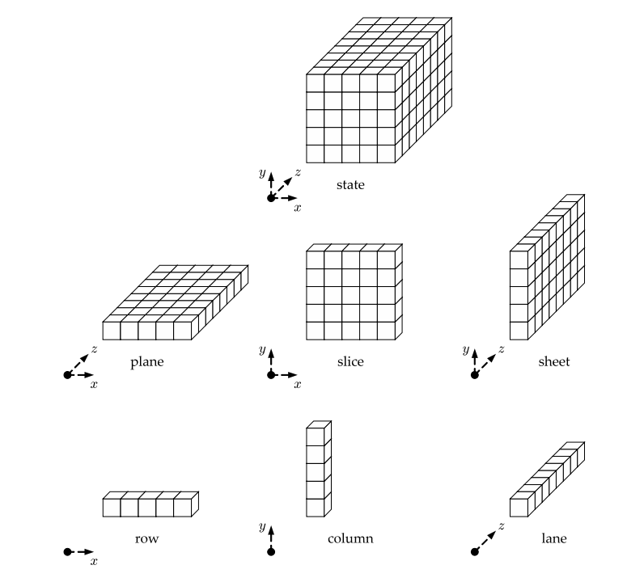
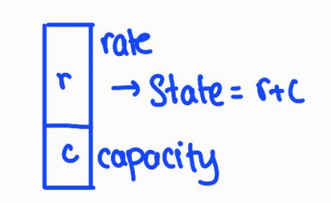

Padding
This operation involves taking an input of any length for hashing, and then concatenating it with appropriate padding inorder to make the total length a multiple of rate (r). This is required to get the input into a specific format for appropriate modes (algorithms).

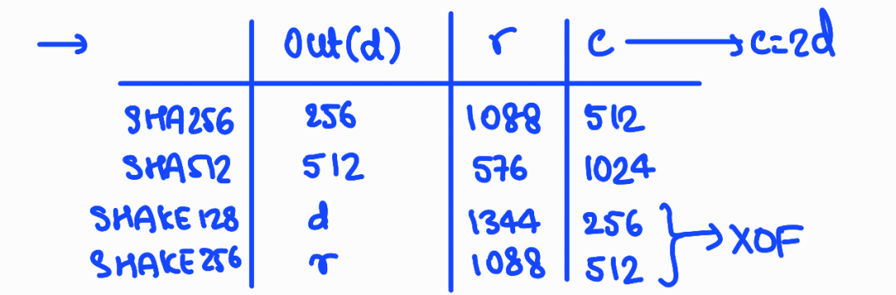

F Permutation
This is the hashing module which executes a series of permutation pre-defined functions on the input data.

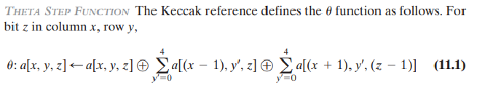

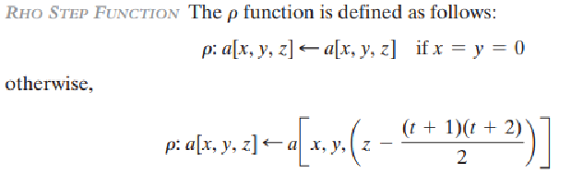

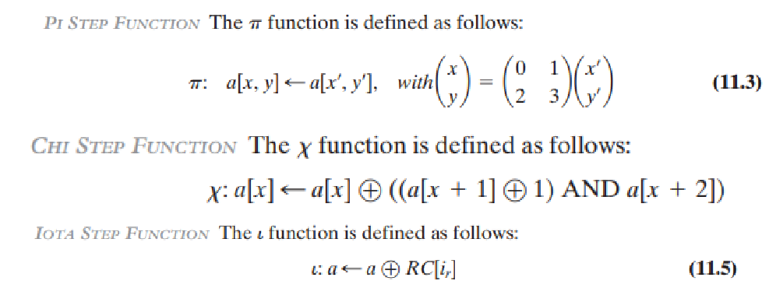

These 5 functions are executed in consecutive fashion, and this constitutes one round. 24 rounds identical to this one are performed, except the round constants which change for every round.
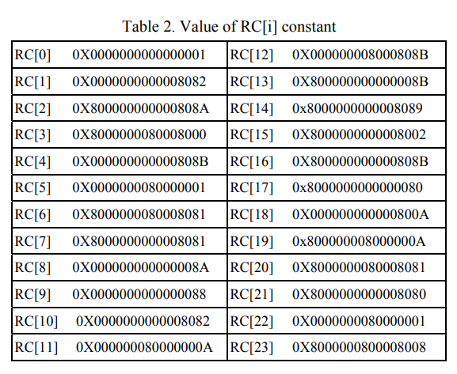
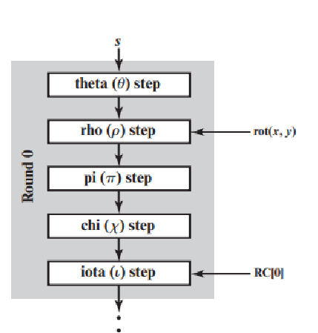

Absorbing
This operation follows after padding the input. The entire input is broken down into sections each of length r. This is XORed with the previous state of the f permutation function (r MSB bits) and fed back into the f permutation block. This process is repeated until the input is exhausted.

Squeezing

This step follows the last absorb stage. Here, we squeeze out r bits at a time, and each squeeze stage is followed by another round of f permutation.
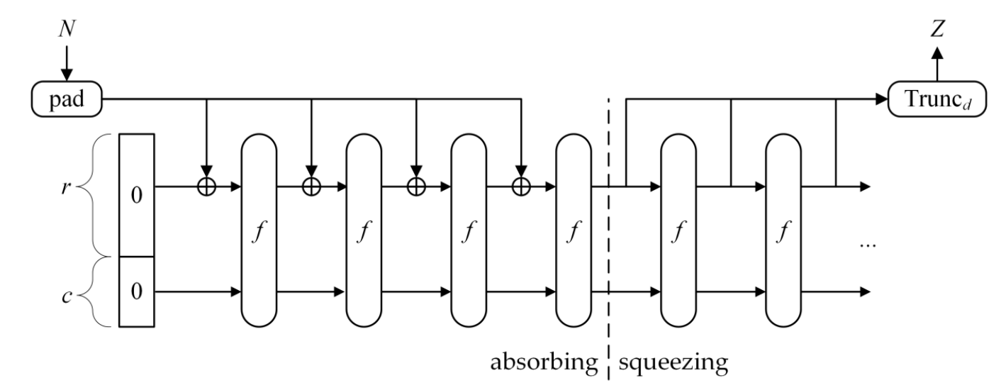

3. Literature Review

1 ) An Efficient Implementation of KYBER [3.6]
The paper contains a hardware implementation of the CRYSTALS-Kyber post-quantum cryptosystem. Kyber is based on the Module-LWE problem and is part of the National Institute of Standards and Technology (NIST) post-quantum cryptography standardization process. Key operations in Kyber, such as modular reduction, Number Theoretic Transform (NTT), and point-wise multiplication, need to be improved. An FPGA platform (specifically Xilinx Artix-7) is used to significantly better performance and resource utilization.
With quantum computers in place, classical public key cryptosystems are more vulnerable than ever before. Kyber is a lattice-based PQC scheme that has progressed to the third round of the NIST PQC evaluation. Drawbacks of software implementations (e.g., on ARM Cortex-M4) and advantages of hardware implementations are emphasized.
- Modular Reduction Algorithm:
  - Modular arithmetic in Kyber involves the modulus q=3329
  - an optimized modular reduction algorithm is proposed to handle the modulus efficiently in hardware.
  - Instead of using standard algorithms like Barrett reduction consuming significant resources, the paper introduces a method that reduces both the high-weight and low-weight bits of the input number, to minimize hardware resource consumption.
  - The modular reduction method uses 24-bit numbers and is optimized for 12-bit multiplications. It has bit-shifting techniques reducing the need for expensive multiplication and addition operations.
- Reconfigurable Data Path:
  - The reconfigurable data path that supports multiple operations such as NTT, INTT, and point-wise multiplication (PWM) needed in Kyber.
  - The data path consists of 12 calculation units: four modular multipliers, four modular adders and four modular subtractors combined dynamically depending on the operation. Thus, resources can be shared across different polynomial operations optimizing hardware usage.
  - Both the Cooley-Tukey (CT) and Gentleman-Sande (GS) methods for NTT computation are supported which brings in parallelism.
- NTT and INTT Operations:
  - The Number Theoretic Transform (NTT) is a form of the Discrete Fourier Transform (DFT) over finite fields in Kyber. It is used to transform polynomials in Kyber.
  - They use two 128-point NTTs for the polynomial’s even and odd parts. This minimizes memory requirements due to an in-place computation technique.
  - A new address generator brings down the register count by 40% compared to traditional methods making the implementation more area and speed efficient.
- Modified Modular Adder:
  - The INTT operation in Kyber involves a × 1/2 operation. A modified adder does this operation directly within the adder without needing separate hardware for the division by two.
  - The adder uses an arithmetic shift operation to handle even and odd values, further improving the speed of the NTT/INTT process.
- Point-Wise Multiplication (PWM):
  - It is another important operation in Kyber’s cryptographic process, requiring multiple modular multiplications.
  - Applying the Karatsuba multiplication algorithm reduces the number of multiplications needed from five to four, saving clock cycles and hardware resources.
- Polynomial Addition/Subtraction:
  - Polynomial addition and subtraction in Kyber are simple operations, but they are optimized in the same reconfigurable data path. These ask for lesser clock cycles and hardware as compared to the complex NTT and PWM operations.
Memory Organization
- SRAM bank is divided into 16 blocks, with each block containing four SRAM cells, supporting 64 12-bit coefficients in each cell.
- The memory organization allows parallel data access, ensuring that two coefficients from a polynomial can be accessed simultaneously, which is required for improved NTT and PWM operations.
- The design provides support for simultaneous reading and writing of data to multiple SRAM blocks, enabling efficient memory access for both the Keccak hash operations and polynomial computations.
HASH Module (Keccak Core)
- Kyber requires SHA-3 hashing and the Keccak core is used for this purpose. Keccak is hardware-friendly. It works as a pseudo-random number generator.
- We see implementation of a low-throughput Keccak core to minimize resource usage while maintaining parallelism with the data path. This core handles both binomial sampling (CBD) and rejection sampling as needed for encryption and key generation processes.
Instruction Set for Data Path Control
- A set of 26-bit instruction codes is defined to control the data path and Keccak core. The instructions include fields for specifying data paths, memory blocks, polynomial operations (NTT, INTT, PWM), and hash operations.
- The instructions also control memory access for read/write operations ensuring seamless execution of polynomial transformations and hash-based sampling.

2 ) FPGA-based tunable Keccak core[3.8]

This paper implements a Multi-cycle design of the keccak core which uses reseedable sponge construction which takes 128 bits from a TRNG that is appended to the state and is squeezed out after the double-sided FIFO runs out of TRNG data. All 5 functions are implemented in a single clock cycle. This paper focuses on building a tunable Keccak core that can be user-configured by modifying parameters like capacity, bitrate, and the number of rounds.
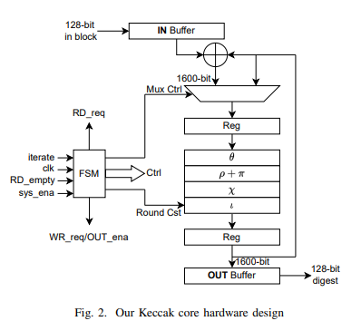
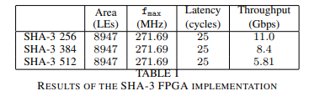

3 ) High Throughput Pipelined Hardware Implementation Of The Keccak Hash Function [3.2]

- This is a pipelined implementation of the Keccak core for SHA-3. The 5 functions are divided into 2 stages, presumable to process two inputs at a time and takes 49 cycles for 2 inputs as in 25 cycles for one input.
- Even though it is highly efficient it is apt for the sampling unit because it cannot handle a high throughput rate
- 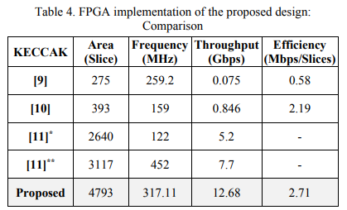
4 ) An optimal hardware implementation of the KECCAK hash function on virtex-5 FPGA[3.4]

Pre-processing Unit: This unit handles padding the message according to the "pad10*1" rule and then dividing the padded message into blocks of equal size. Finally, it converts the data into a 1600-bit state matrix represented as a 3D array.

Processing Unit: This unit contains the core Keccak logic, performing 24 rounds of the compression function, each with five steps: Theta (Θ), Rho (ϱ), Pi (π), Chi (χ), and Iota (ι). The mathematical formulas for these permutations are presented in the paper.

Control Unit: Implemented as an FSM, it manages the data flow and synchronization between different modules of the SHA-3 core.
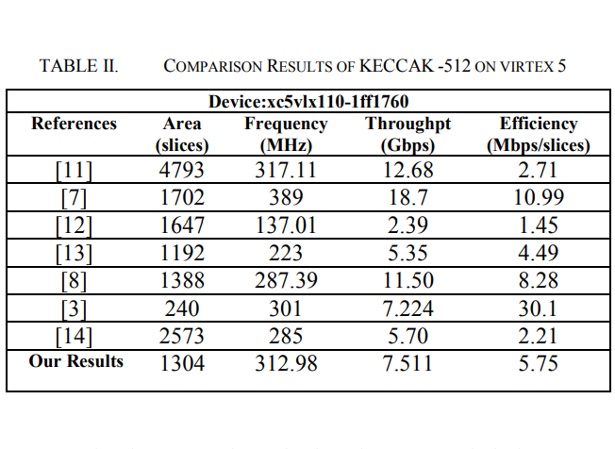

Hardware Implementation

Padder:

The Padder module is a hardware component to prepare input data for cryptographic operations by means of necessary padding. It makes sure the input data meets specific requirements for size or format before being passed on to the next stage of processing. Here is how it works:
Inputs:
clk (clock): It synchronizes the module’s operations.
rst (reset): Resets all internal states and signals to their initial state.
in: A 64-bit input data signal.
in_valid: Indicates when the input data is valid.
start_calc: Signals the start of a calculation, initializing the module.
takein: Indicates when data is ready to be taken in for processing.
is_last: It signals if the current data block is last in sequence.
mode: It is a 2-bit input to specify the padding configuration ( out of 4 possible configurations).
Outputs:
out: It is the 64-bit data output which has been padded as needed.
out_ready: It is a signal used to mean the output is ready for use.
ack: It is used to send an acknowledgement that input data has been gotten and processed.
cntr_zero: It is high when the internal counter has come to zero.
takein_reg: It is the latched takein signal and marks if input data is valid.
Internal Registers and Signals:
pad_out: It holds the padded output data.
cntr: It acts as a counter tracking padding progress based on the selected mode.
latch_last and latch_latch_last: They help to manage the handling of the last data block.
pad: It signals when padding is being added.
Functionality:
Counter Management:
The counter (cntr) determines how many cycles of padding or data processing are needed:
When start_calc or takein is high and the input is valid, the counter is loaded with a value based on the mode:
Mode 0: 17 cycles.
Mode 1: 9 cycles.
Mode 2: 21 cycles.
Mode 3: 17 cycles.
As data is processed or padding is done, the counter reduces till zero is reached.
Handling Input Data:
Input data (in) is latched into pad_out when:
Input is valid but not the last block (is_last is low) or it is the last block but padding is still left to be done.
Adding Padding:
If the last block is processed and padding is needed, the module appends padding bits:
A special pattern is used for padding, such as a single 1 bit followed by 0s.
If no further padding is required, pad_out is set to zero.
Output Readiness:
The module makes out_ready high when output is ready. This happens when either padding is being added or valid input data is being processed. If none of the conditions is true, out_ready goes low.
Acknowledgment Signal:
The ack signal means that the module has successfully received and then, processed input data.
Last Block Management:
latch_last is used to make sure the correct handling of the last data block so that it transitions smoothly to padding if required.
Output Data:
Final padded output is given to the out signal which is available when out_ready is high.
Padding Process in Detail:
Counter Initialization:
When start_calc or takein is high and in_valid is high, the counter (cntr) is initialized depending on the selected mode. This decides how many cycles are needed to process and pad the input data.
Data Input and Padding:
Valid Data Handling: If in_valid is high and padding is not yet needed, there is latching of input data into the pad_out register.
Last Block Handling: If current block has been marked as the last (is_last), the module ensures padding bits are added after this if sufficient input bits have not been received. For example:
A string of zeros sandwiched between two ones is chosen as multirate padding.
Output Readiness:
The out_ready signal becomes high whenever valid padded data is present at the output. This permits modules downstream to process the data without delays.
Acknowledgment Signal:
The ack signal is used to confirm that the module has received and processed a valid input block. This facilitates smooth operation in systems when multiple blocks are to be processed sequentially.
Completion Signal:
When the counter (cntr) comes down to one, cntr_zero signal goes high which means that the padding process is complete.

Multirate padding used: [3.7]
The module adds padding to input data to so that it fits the necessary size for processing. Three types of padding patterns are used depending on where the input data ends and amount of padding still needed. These patterns are according to cryptographic rules making data ready for algorithms like SHAKE-128, SHAKE-256, SHA-256, or SHA-512.
Types of Padding Patterns and Their Roles
1. 1...000 (a single 1 followed by zeros)
This pattern starts the padding process when the input data ends.
When it is used:
After the last block of input data is received (when is_last is active).
At the beginning of the padding process, generating the first block of padding.
Why it is needed:
This pattern shows the start of padding, with the 1 bit marking the beginning and the zeros filling up the rest of the block. Cryptographic standards like multirate padding require this format to prepare data for algorithms.
How it works in the module:
If the last block flag (latch_last) is active and the counter (cntr) is not 1, the module sets pad_out to 1...000 (a single 1 followed by 63 zeros).
else if (latch_last & cntr != 1) begin
pad_out <= {1'b1, {63{1'b0}}}; // Single '1' followed by zeros
end
2. 0...0 (all zeros)
This pattern keeps adding zeros during the padding process after the initial 1...000 block.
When it is used:
After the first padding block is generated, when more padding is still needed or when there is no more input data, and zeros are needed to fill the block to the required size.
Why it is needed:
It helps to make sure that the block is fully padded to match the required size, adding zeros is a simple and efficient way to complete the padding.
Working:
If counter (cntr) is not 1 or 0, pad_out is filled with zeros.
else if (cntr != 1 & cntr != 0) begin
pad_out <= 0; // Fill remaining blocks with zeros
end

3. 0...1 (all zeros with a single 1 at the end)
This pattern finishes padding by signifying the end of padded data.
When it is used:
In the last padding cycle when the counter (cntr) reaches 1 ie, at the end of the padding process to signal completion of the process.
Why it is needed:
This pattern makes the last block of padding distinct and thus, data meets cryptographic format requirements.
Working:
When the counter (cntr) equals 1, the module sets pad_out to 0...1 (all zeros with a 1 as the last bit).
else if (cntr == 1) begin
pad_out <= 1; // Final padding block with a '1'
end
Why Multirate Padding Is Important:
Adding these specific patterns:
Helps cryptographic algorithms like SHA-256, SHA-512, and SHAKE variants process data efficiently.
Ensures the padded data follows strict rules, making it compatible with the algorithm’s internal functions.
Provides a clear structure to the padded data, making the start and end of the padding easy to identify during processing.

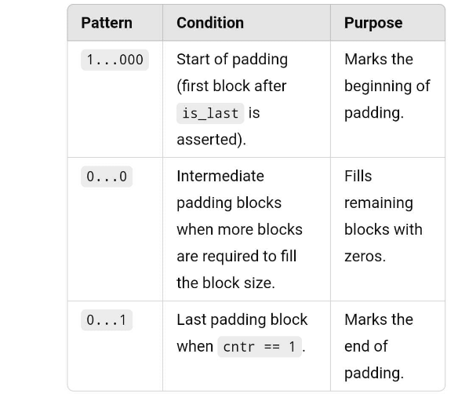

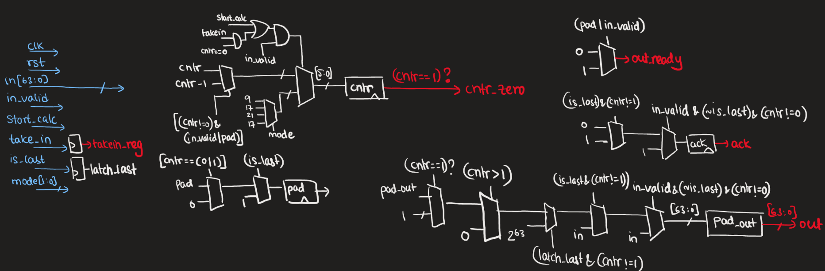
1. Padder module

FIFO(First In First Out):
We plan to use a fifo to buffer the outputs from the f_permutation function. The data from FIFO is read by the sampling unit that follows the keccak core.
The Sync_FIFO module is a effective design that is simple too for managing data flow between two components in a system ( here two modules in the core) ensuring that data is processed in the same order in which it is received. It is truly useful in systems like Post-Quantum Cryptography (PQC) as maintaining smooth and orderly data transfer is important.
Function:
The Sync_FIFO acts like a queue for data. Data goes in one end (write), stays temporarily in a storage area (buffer), and comes out the other end (read) when needed. Its principle is that the first piece of data to go in is the first to come out. We can think of it like a line at a ticket counter—first come, first serve.
Inputs and Outputs:
Inputs:
clk (Clock):
The clock signal is a periodic signal for the FIFO making sure everything inside works in sync.
rst (Reset)
Resetting the FIFO clears out all data and puts everything back to its starting position.
wr_en (Write Enable)
It tells the FIFO that new data is ready to be written into the buffer.
rd_en (Read Enable)
It signals the FIFO to provide data from the buffer for reading.
buf_in (Data Input)
This is where the data that needs to be stored comes in. It is 64 bits wide, which means it can handle large chunks of data at once.
Outputs:
buf_out (Data Output)
This is where data leaves the FIFO when it’s being read.
buf_empty (Empty Flag)
It specifies when the FIFO is empty and there is no data to read.
buf_full (Full Flag)
It signifies that the FIFO is full and cannot accept any more data.
out_valid (Output Validity Flag)
It informs when the data at the output (buf_out) is valid and ready to use.
Working:
Keeping track of the data:
The FIFO uses some key elements to manage everything inside:
buf_mem is the storage area where data is kept temporarily. Think of it like shelves in a warehouse.
Pointers keep track of where to write or read data:
wr_ptr (write pointer) shows the next spot where data will be stored.
rd_ptr (read pointer) shows the spot where the next piece of data will be read from.
fifo_counter counts how many pieces of data are currently stored. It’s like a quick way to check how full or empty the buffer is.
Buffer Status:
The module constantly checks whether the buffer is empty or full:
When the counter (fifo_counter) is zero, it means the buffer is empty, and buf_empty goes high.
When the counter reaches the buffer’s maximum capacity (BUF_SIZE), it means the buffer is full, and buf_full goes high.
Writing Data:
Writing happens as and when wr_en is active and the buffer is not full:
It carries data from buf_in and stores it in the location directed to by wr_ptr.
The wr_ptr moves to the next location and so, next piece of data knows where to go.
It increments the fifo_counter considering that new data has been added.

Reading Data:
Reading happens when as and rd_en is active and the buffer is not empty:
It carries data from the location pointed to by rd_ptr and sends it to buf_out.
The rd_ptr moves to the next location and thus, next piece of data can be read.
It decrements the fifo_counter taking into account that data has been removed.
It also sets out_valid to signify that the data at the output is valid.
Doing both read and write at the same time:
If both wr_en and rd_en are active and the buffer is neither full nor empty, the module can handle it smoothly:
It updates both pointers so that data can be written and read simultaneously.
The fifo_counter doesn’t change since the number of stored data pieces stays the same.
Resetting the FIFO:
When rst is active, the FIFO clears everything:
It resets the counter (fifo_counter) to zero.
It resets the pointers (wr_ptr and rd_ptr) to their starting positions.
It clears any stored data and resets the status flags (buf_empty, buf_full, and out_valid).

SIPO(Serial In Parallel Out):

data_in :the input
hash_init: reset signal
load_en: loads in input when padder gives valid data and f_permutation is not processing.
This module processes 64-bit chunks of data and collects them into a big 1344-bit register. It does so by performing left shift of the existing data in the register and inserting each new 64-bit chunk into the least significant 64 bits. The module also uses control signals to reset its state, enable data loading, and indicate when all chunks have been loaded.
Thus, the module:
Collects 64-bit input data one piece at a time.
Builds up a 1344-bit output register.
Notifies when the register is fully loaded and ready for use.
Inputs and Outputs:
Inputs:
data_in: A 64-bit chunk of data, which is added serially to the register.
hash_init: A reset signal that clears the module’s internal state and prepares the register for new data.
load_en: It is a signal which permits loading the 64-bit data into the register.
clk: It is the clock signal driving the module’s operations and syncs everything.
cntr_zero: This is a signal activated when all the chunks have been loaded.
calc: It is a signal used to check the state of the loading process.
Outputs:
data_out: It is a 1344-bit register storing aggregated data.
is_loaded: It is a signal indicating that the register is completely filled and ready for processing.
Working:
Module reset:
When hash_init signal is active,
Whole (each bit in) data_out register is cleared (set to 0).
Flags such as is_loaded and is_loaded_temp are also reset to 0.

Loading Data:
When load_en signal is active:
Current contents of data_out are shifted left by 64 bits.
New data_in chunk is placed into the least significant 64 bits of data_out.
This allows new chunks of data to be added to the register, one after another.
Signaling Completion:
The cntr_zero signal indicates if the register is completely filled with the required chunks of data.
When active, a temporary flag (is_loaded_temp) is set to 1, signaling the register is full.
If no more calculations are necessary (when the calc signal is not active), the module resets is_loaded_temp to 0.
Updating Output Flags:
The is_loaded output mirrors the state of is_loaded_temp.
This flag updates in accordance with the clock providing reliable and glitch-free information about whether the register is full and ready for the next step.
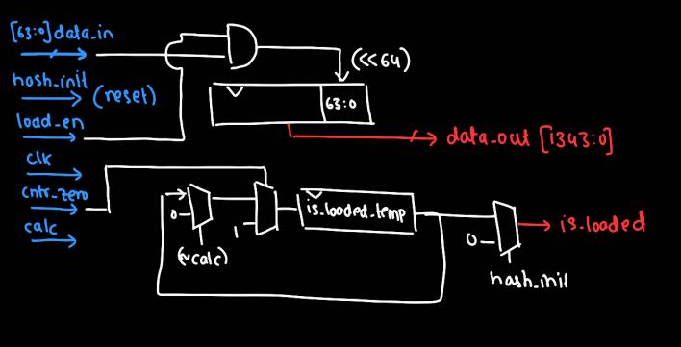
Fig2.SIPO module

F(permutation function):

The f_permutation module is a key part of the working of the Keccak algorithm. Keccak is the foundation of SHA-3, a modern and secure way of creating hash values. Essentially, this module takes some input data, scrambles it with a series of steps and gives back a transformed result.
It processes the input given for specific modes. The input is sliced to be padded to its format and then it is xored or passed on depending on the squeeze signal. Calc signifies calculation by the f_permutation which in turn is used for updating the output register. i is a 23-bit register which acts as a round selector which is in one hot encoding.

Function:
Takes Input: It starts with a data block of size 1344 bits.
Processes it: It runs the data through a series of "rounds" for transformation.
Gives Output: It gives a final result that is 1600 bits long. It can process input in various ways and output depending on what is required, for example, combining data (absorbing) or squeezing it for a final outcome.
Inputs and Outputs
Inputs:
clk: A clock signal to keep the process in sync.
reset: It is used to reset everything to a clean slate.
in (1344 bits): The data to be processed.
in_ready: It is used to signal the module that input is ready.
mode (2 bits): Tells the module how much of the input is to be combined with the current state:
o mode = 0: XOR first 1088 bits of in with the state.
o mode = 1: XOR first 576 bits of in with the state.
o mode = 2: XOR all 1344 bits of in with the state.
o mode = 3: XOR first 1088 bits of in with the state.
squeeze: It is used to signal that output is to be generated.
pack: Marks the phase where input data is being processed.
last_in: Shows this is the last block of input in a sequence. This is a latched signal.
first_last: It is a pulse to indicate last block of input.
Outputs:
out (1600 bits): The final data that has been transformed.
out_ready: It signals that the output is ready to be used.
ack: It is used to confirm that the input has been processed.
calc_out: Shows the module is busy processing.

Internal Components and Signals
Registers and Flags
i (23 bits): This is used to keep track of the round the module is currently on and helps to manage transitions between rounds.
calc: It is a flag that shows if the module is actively working on round calculations.
round_in (1600 bits): The state fed into a Keccak round.
round_out (1600 bits): It is the state that comes out after a Keccak round is done processing.
rc (64 bits): This is the round constant used in the current round.
last_in_reg: It keeps track of whether the current block of input data is the last one in sequence.
Round Modules
rconst: This module gives the round constant (rc) based on the current round number (i).
round: This is where the main Keccak transformations happen in every round. It has the following steps:
Theta (θ): Used to mix columns in the state to spread information across bits.
Rho (ρ): Used to rotate bits adding more randomness.
Pi (π): Used to rearrange the state ensuring the bits are shuffled further.
Chi (χ): Used to add a non-linear substitution to increase complexity.
Iota (ι): Used to add a unique round constant in order to break symmetry.
Control Signals
accept: This signal allows the module to take in new input data when it is ready, also, not currently processing.
update: It indicates that the state will be updated in the next clock cycle.
Functional Workflow:
1. Initialization
When the module is reset:
Round counter (i) is cleared to begin from the first round.
Output state (out) is reset to zero.
Flags like calc and out_ready are cleared to make sure the module is ready for new input.
2. Input Absorption
If the module is not busy calculating and input is ready (i.e, accept is high):
The round_in state is prepared by combining the input data (in) with the current state (out) using XOR, based on mode selected.
If input is the last or first block, the module updates the last_in_reg flag so that it can keep track.
3. Permutation Rounds
When the input is absorbed, the module starts processing:
It ventures into the calculation phase (calc is set to 1).
The rconst module outputs round constant (rc) for each round.
The round module applies the Keccak-f transformations steps.
4. Output State
After all rounds are complete:
Final state is stored in out.
If the current block was the last one, the module sets out_ready to say the output is valid and ready to be used.
5. Squeezing Phase
If squeezing signal is on, the module processes the state ahead to extract blocks of data. This is also used for hashing etc.
Control Signal Behavior
calc: It turns on when the module is performing Keccak rounds, turns off once all rounds are done.
accept: It turns on when the module is ready to take new input and remains active during the phase of input absorption.
update: It signals that the state will be updated when the next clock cycle comes.
out_ready: It activates only after the final round, signaling that the output is valid, ready to be made use of.
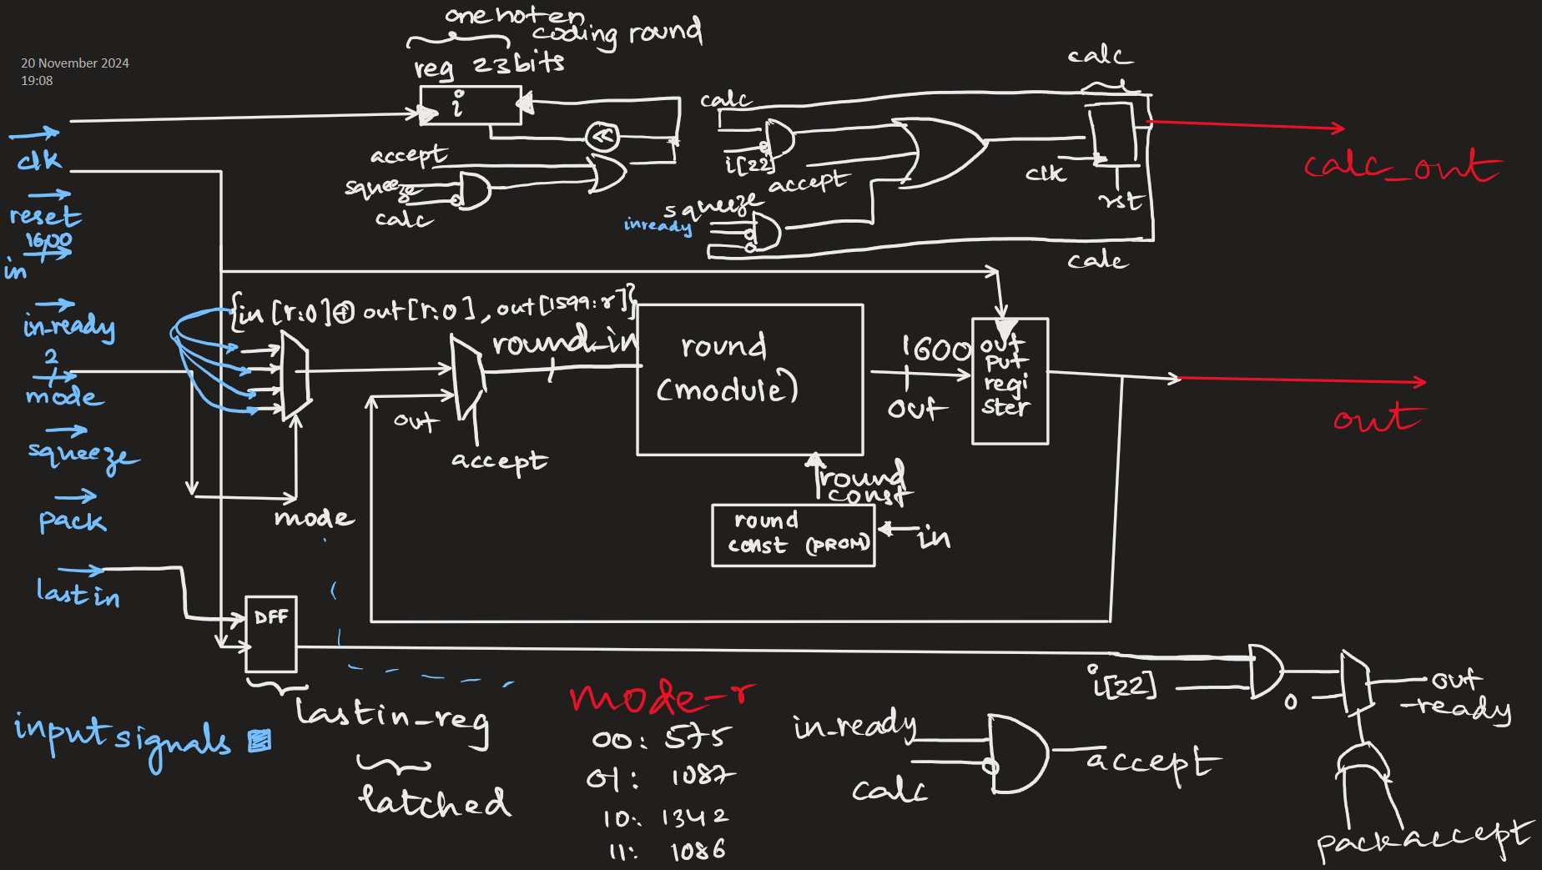
F_permutation module

Round:
The Round module is a pivotal component in the hardware implementation of the Keccak core, which underpins SHA-3 and related cryptographic algorithms like SHAKE. This module executes a single permutation round of the Keccak sponge function, a process involving five distinct operations—Theta, Rho, Pi, Chi, and Iota. Each of these steps contributes to ensuring the diffusion, non-linearity, and cryptographic security of the Keccak hash function.

Inputs and Outputs
Inputs
in (1600 bits): the Keccak state matrix, 5x5 grid of 64-bit lanes. In the context of the function, it is the starting point of every round
round_const (64 bits): unique round constants, utilized in the Iota step, which ensures a degree of asymmetry in the state and enhances the overall strength against cryptographic attacks
Outputs
out (1600 bits): the output state matrix after all five steps applied within the round function
Structure and Functionality
The Round module encompasses the five main rounds of the Keccak permutation. Each round transforms the state matrix in a way that contributes to the cryptographic robustness.

1. Theta Round
The Theta round ensures diffusion across the state matrix by XORing each bit with the parity of two columns.
Implementation Details:
Intermediate wires a[x][y] store the input state, decomposed into 5x5 lanes.
A parity vector b[x] computes the XOR of all lanes in a column.
The output of Theta, c[x][y], is derived by XORing each lane with a shifted parity from neighboring columns.
This step ensures that every bit is influenced by bits in its column, spreading information throughout the matrix.

2. Rho Step
The Rho step applies cyclic bitwise rotations to each lane of the state matrix.
Implementation Details:
Specific rotation offsets are defined in the code for each lane to get unique permutation for each position
For example, d[2][0] is shifted version of c[2][0] with a shift of 62, while d[0][0] is the identity.
The Rho step is crucial towards addressing symmetry issues within the matrix and improving mixing among bits.

3. Pi Step
Pi step shuffles lanes of state matrices, reorders them according to predefined positions.
Implementation Details:
Lanes from d[x][y] are relocated to new positions in e[x][y], which forms a permuted state.
For example, e[0][2] is equivalent to d[1][0] as per Pi mapping.
As a result of this step, it allows further diffusion since it relocate the adjacent bits in the matrix.

4. Chi Step
This step applies a nonlinear transformation over each row of the state matrix.
Implementation Details
A new value f[x][y] is calculated for every lane, using the formula:
n f[x][y]= e[x][y]⊕((∼e[x+1][y])∧e[x+2][y])
This step introduces non-linearity, important for any resistance to linear cryptanalysis.
The Chi step makes each bit depend non-linearly on its neighbors in the row.

5. Iota Step
The Iota step introduces round-specific constant to the state matrix, resulting in broken symmetry and, hence, identical inputs are bound to diverge differently in rounds.
Implementation Details:
The round constant round_const is XORed with the first lane, f[0][0].
Remaining lanes are passed through unchanged to g[x][y].
The Iota step ensures that for the same initial states, the rounds of the permutation could be unique.

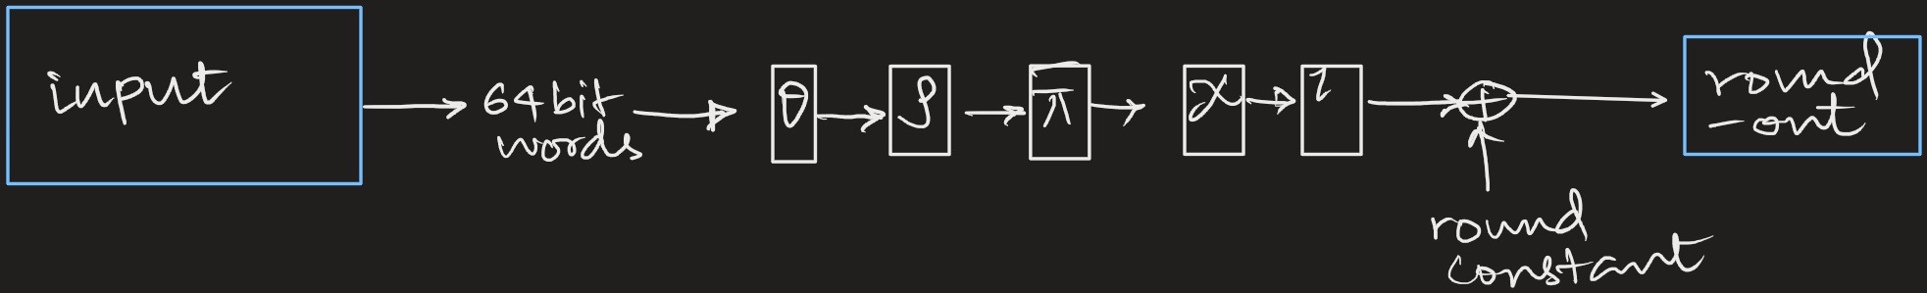
Round module

PISO(Parallel In Serial Out):
The output from the f_permutation is latched and saved in PISO register and output is given 64 bits at a time and the number of cycles the out_ready depends on the mode of operation
This module takes a bigger block of data: 1344 bits wide and breaks it into smaller chunks so they can be sent one at a time. It works based on a clock signal and uses control signals to do the following:
Load Data: When we turn on the load_en signal, the module takes all 1344 bits of input data and stores it inside.
Output Data in chunks: It splits stored data into smaller pieces (like 64 bits at a time) to send them out starting with the biggest chunk.
Shift Data: After sending out a chunk, it shifts the stored data to prepare next chunk for output.
Show Ready Status: A signal called out_ready lights up to inform that the module is ready to send data.
This module is like a machine that packs and sends small parts of a big package.
Inputs and Outputs
Inputs:
data_in (1344 bits): The big block of data to be sent in chunks.
rst: It is a reset signal clearing everything to start fresh.
load_en: It is used as a switch to load the big block of data into the module.
shift_en: It is a switch which signals to start sending out data chunks one by one.
clk: A clock signal to keep all movement in sync.
count_zero: A signal (used outside this module) that can help track when all data chunks have been sent.
Outputs:
data_out (64 bits): The smaller chunk of data currently being sent out.
out_ready: A signal to show the module is ready to send data.
pack:Acknowledge back to the f_permutation.
Working:
1. Resetting the Module
If the rst signal is on:
Stored data is cleared (set to zero).
out_ready signal is turned off to mean that no data is ready.
This ensures the module starts afresh every time.
2. Loading Data
If the load_en signal is on:
The module takes the 1344 bits from data_in to stores it.
It turns on the out_ready signal signaling it’s ready to send chunks.
3. Sending Chunks
If the shift_en signal is on:
The module gives out the first chunk of data (e.g., 64 bits) from the stored block.
Then it shifts the data to the left getting the next chunk ready.
It repeats this process for each clock cycle until every chunks is sent.
4. Showing Readiness
The out_ready signal works like this:
It turns on when the module loads data (load_en is on).
It turns off when the sending process (shift_en) is paused or finished.
Control Signals
rst: Resets everything to zero and clears the module.
load_en: Loads the 1344 bits into the module and sets the out_ready flag.
shift_en: Starts sending chunks and shifts the data inside.
count_zero: Not used directly here, but it’s helpful in larger systems to know when all chunks are sent.
Two Phases:
Loading: When load_en is on, the big data block is loaded into the module.
Sending: When shift_en is on, the module is sending chunks one at a time.
The out_ready is like a "ready-to-go" light letting us know when the module is ready. With its setup, this module is useful for splitting big blocks of data into smaller pieces so that they can be handled easily.

The MUX inputs which become the cntr value of the counter used with PISO based on mode are:
Mode 0- SHA 256: cntr- 4 as fixed output size of 256= 4*64.
Mode 1- SHA 512: cntr- 8 as fixed output size of 512= 8*64.
Mode 2- SHAKE 128: cntr- 21 as (1600-2*128)/64= 21
Mode 3- SHAKE 256: cntr- 17 as (1600-2*256)/64 = 17

The PISO uses the cntr to know in how many times is the output completely sent to the FIFO (output buffer) in chunks. The PISO selects the 1344 MSBs ( bits) from the 1600 bit output of the f_permutation module. It leaves out the rest of them.
When shift_en is asserted (high), the data register is shifted left by DATA_SIZE bits in every clock cycle.

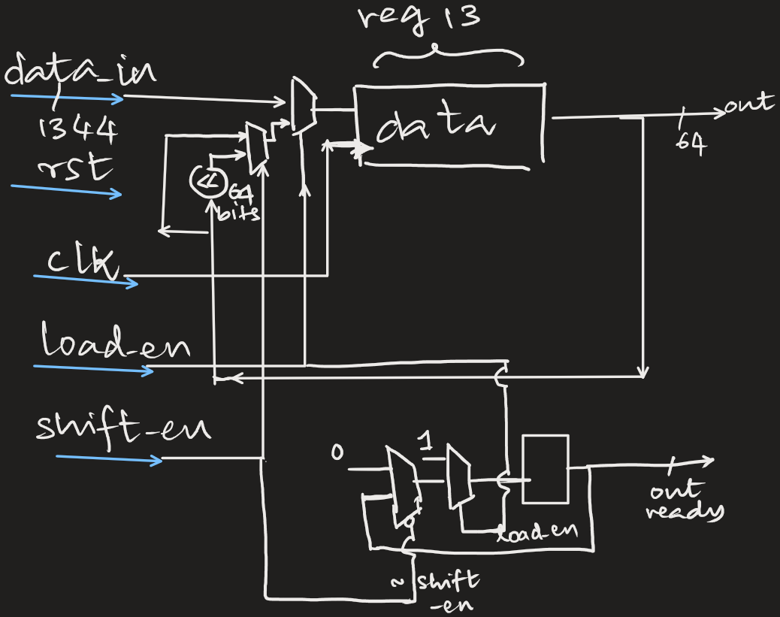

Keccak_v1(Top):
The Keccak module processes data for cryptographic needs. It takes input, performs steps to transform the data and produces secure outputs. Each part of the system has a particular job and they all work together to ensure smooth and secure running of the process.
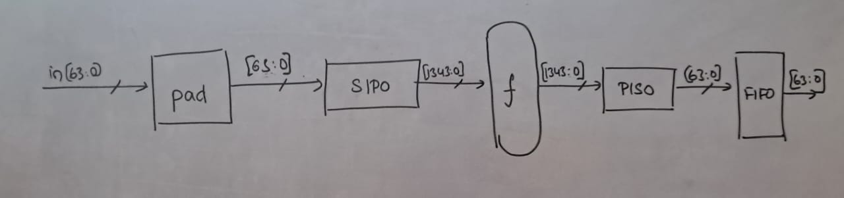
Inputs and Outputs:
Inputs:
Clock (clk): To keeps the module running at the right speed.
Reset: To restart the system as and when needed.
Input Data (in): The 64-bit data fed in that needs to be processed.
Input Ready (in_ready): A signal that says the input data is ready to use.
Read Enable (rd_en): Allows data to be read when necessary.
Mode: This selects how many outputs we will get:
Mode 0: 4 outputs
Mode 1: 8 outputs
Mode 2: 21 outputs
Mode 3: 17 outputs
Squeezing Cycles (num_squeeze): Decides how many cycles of data squeezing to perform.
End Seed: Lets the system know there is no more data to input.
Start Calculation (start_calc): Tells the system to start processing.
Outputs:
Output Data (out): The final 64-bit processed data.
Output valid (out_valid): Says when the output is valid to be used.
Buffer Full (buf_full): Warns when the system’s internal storage is full.
What’s Inside the Module?
The Keccak module uses a mix of smaller parts to get the job done:
Shift Enable (shift_en): Moves data where it needs to go during processing.
Buffer Empty (buf_empty): Signals if the internal storage is empty.
Permutation Output Ready (f_out_ready): Signals that the processed data is ready for the next step.
Core Components:
Sync_FIFO: A temporary space holding the input data.
SIPO (Serial-In Parallel-Out): Changes incoming data from a single stream into a large block format for processing.
f_permutation: The part of the system applying all the cryptographic transformations.
PISO (Parallel-In Serial-Out): It changes the processed block back into smaller chunks, helps to make the output easier to use.
Working:
1. Taking in the Data and readying it:
The system begins by taking in raw data through input in. Signals like mode and start_calc determine handling of the data. If the data doesn’t fit the system’s block size, a padder adjusts it to make it fit. This makes sure everything runs smoothly and securely.
2. Converting Data for Processing:
Once the data is ready, the SIPO module changes it from a single stream into a large block format that the processing core can handle. Special signals make sure this step is in sync and ready for next phase.
3. The Main Processing:
The heart of the system is the f_permutation module. This is cryptographic transformation steps happen. It applies multiple steps to transform the data, making it secure and hard to reverse bringing in cryptographic entropy.
4. Preparation of Output:
The PISO module takes big chunk of data when processing is completed in f_permutation. It is broken up into small 64-bit chunks. This makes the output easier to handle when passed on to other systems.
5. Storage and Delivery of Output:
Finally, smaller data chunks are stored in a FIFO buffer until they are ready to be used. Signals such as buf_full and out_valid help in managing this step avoiding errors like overflows or missing data.
End-to-end flow:
Simple signals are used to keep things running smoothly:
out_valid: informs when the processed data is valid.
ack: Confirms that input data has been received and also, processed.
Counters: Keep track of number of steps completed based on mode selected.
The process:
Input Stage: The raw data comes in and gets adjusted as per necessity.
Preparation: The data is converted into a block format for processing.
Processing: The core module transforms the data securely.
Output Preparation: The transformed data is broken down into smaller pieces.
Delivery: The data is stored in a buffer and sent out when it is ready.
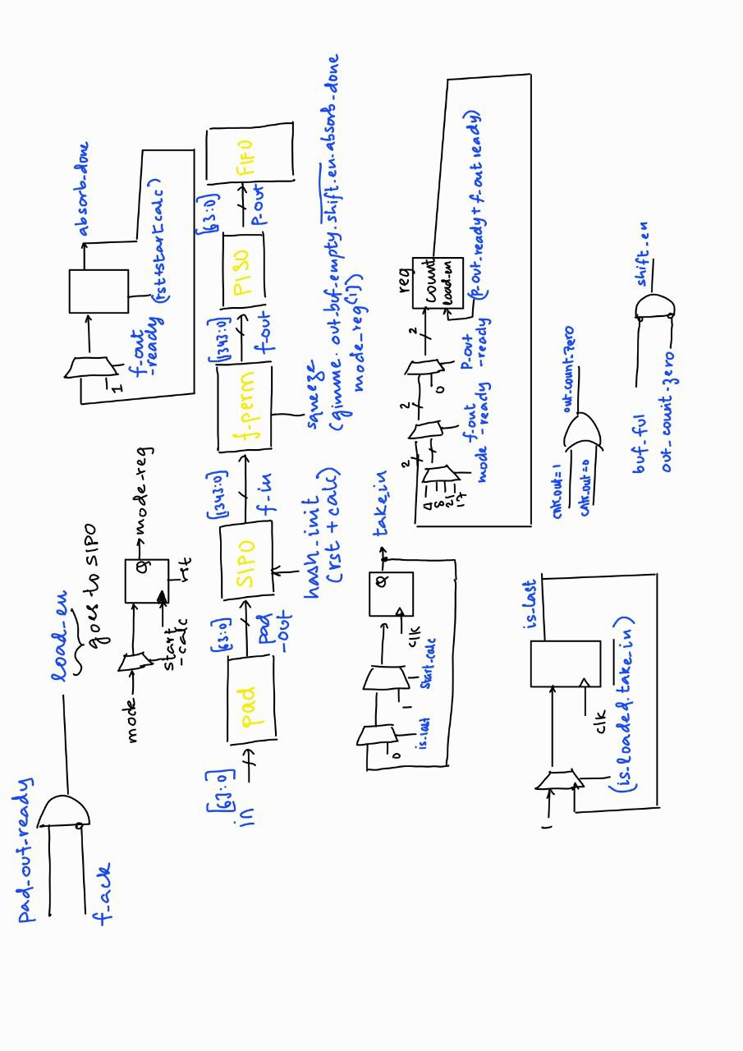
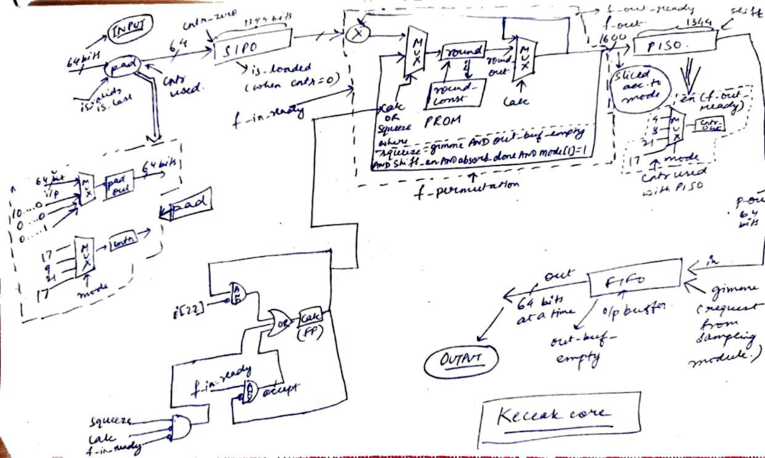

5. Bibliography
  - Bisheh-Niasar, Mojtaba, Reza Azarderakhsh, and Mehran Mozaffari-Kermani. "Instruction-set accelerated implementation of CRYSTALS-Kyber." IEEE Transactions on Circuits and Systems I: Regular Papers 68.11 (2021): 4648-4659.

  - Mestiri, Hassen, et al. "High throughput pipelined hardware implementation of the KECCAK hash function." 2016 International Symposium on Signal, Image, Video and Communications (ISIVC). IEEE, 2016.

  - Maache, Ahmed, and Abdesattar Kalache. "FPGA-based tunable Keccak core." 2023 International Conference on Smart Applications, Communications and Networking (SmartNets). IEEE, 2023.

  - Assad, F., et al. "An optimal hardware implementation of the KECCAK hash function on virtex-5 FPGA." 2019 International Conference on Systems of Collaboration Big Data, Internet of Things & Security (SysCoBIoTS). IEEE, 2019.

  - Dworkin, Morris J. "SHA-3 standard: Permutation-based hash and extendable-output functions." (2015).

  - Guo, Wenbo & Li, Shuguo & Kong, Liang. (2021). An Efficient Implementation of KYBER. IEEE Transactions on Circuits and Systems II: Express Briefs. PP. 1-1. 10.1109/TCSII.2021.3103184.

  - Cryptogra-phy, Elliptic Curve. "William Stallings. Cryptography and Network Security Principles and Practices." PGM334401. htm.

  - Maache, A., & Kalache, A. (2023, July). FPGA-based tunable Keccak core. In 2023 International Conference on Smart Applications, Communications and Networking (SmartNets) (pp. 1-6). IEEE.

